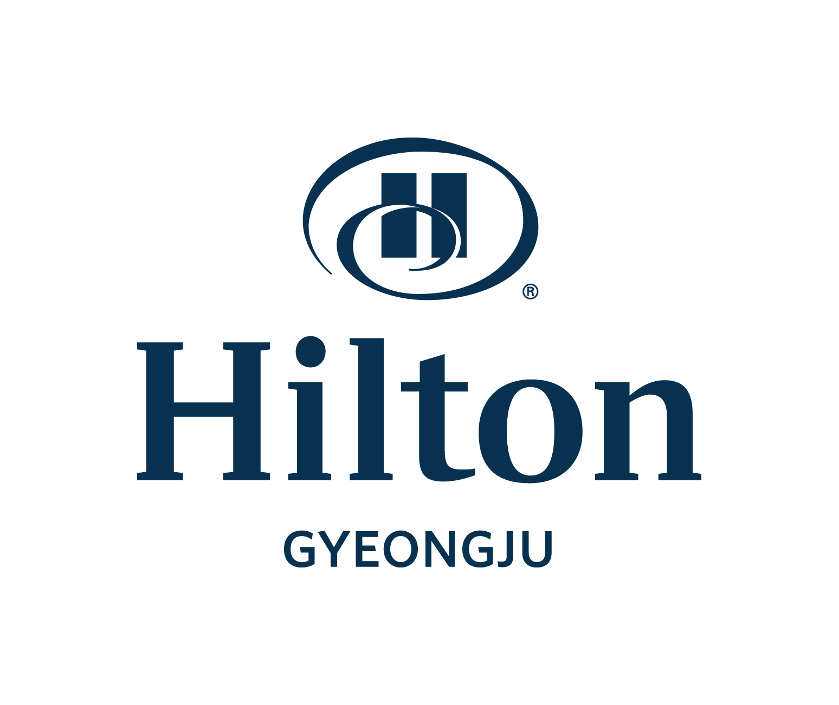
Hotel Reservation Form
(16th KSID Research Camp)

August 25 ~ 27, 2009

*Please complete this form with all requested information and send it to our hotel directly by e-mail or fax.
E-mail: donghyo.seo@hilton.com Fax: +82-54-745-7799, Phone: +82-54-740-1232~4, +82-54-745-7788

Participant Information
First Name: Last Name: Title: □Mr. □Ms.
Company Name : Position:
Sharing Room with First Name(Optional): Last Name(Optional):
Phone: Fax: E-mail:
Arrival Date : Departure Date: No. of Nights:
Special request and comments :
Non-smoking : All Rooms (Not available smoking room)

Accommodation Information (Sep.25~27, 2025)
Room Type | Rate /Day | Remark
Single Room/ Twin Room | □ KRW 210,000, (9/25, Thu.) | *Room Only
Single Room/ Twin Room | □ KRW 245,000, (9/25, Thu.) | Inclusive of breakfast for 1Per.
Single Room/ Twin Room | □ KRW 230,000, (9/26, Fri.) | *Room Only
Single Room/ Twin Room | □ KRW 265,000, (9/26, Fri.) | Inclusive of breakfast for 1Per.
Single Room/ Twin Room | □ KRW 315,000, (9/27, Sat.) | *Room Only
Single Room/ Twin Room | □ KRW 350,000, (9/27, Sat.) | Inclusive of breakfast for 1Per.
* 10% service charge & 10% VAT are included in the above rates.
* Free Wireless Internet for 24 hours
* Breakfast buffet: Lakeside Café (06:30-10:00)
* An additional charge of KRW 50,000 will apply if breakfast buffet is added on site.

Payment Information
In order to guarantee your reservation, your credit card information must be accompanied.
□ AMEX □ VISA □ Master □ Dinners □ JCB □ Other( )
Card No.: Expiration Date(mm/yy)
Cardholder’s Name: Date: Signature:

Cancellation Policy
If you wish to cancel, please do so 5 days prior to arrival to avoid cancellation penalties.
(취소 위약금이 발생하지 않도록 하려면, 도착일 기준 5일전에 취소 하시기 바랍니다).

Hotel Use Only
Confirmation No.: Reservation:

